**Game Design Document**

**Fill up the following document :**

1. Write the title of your project.

Robo Re-Encounter

1. What is the goal of the game?

The Goal Of The Game Is To Get The Tons Of Kills And To Mentain Your Kill Streak In A Row In Order To Get A Lot Of XP To Level Up.

1. Write a brief story of your game.

The Main Screen Will Have All The Options Like The Item

Shop, Choice Of Maps, Avatar Customisation, Notifications,

To Choose Whether You want a Public Or A Private GAme.

Once you press play you will load into a public game or

Private game as chosen. If you want you can have bots in

your private game. In order to get xp you have to get   
kills which will level you up. Kills can also get you coinswhich you can save up for your favourite items from the item shop.

1. Which are the playing characters of this game?

* Playing characters are the ones who respond to the user based on the input from the user.
* Cars, monkeys, dinos, wizards, etc., are the playing characters in the game.

|  |  |  |
| --- | --- | --- |
| Number | Character Name | What can this character do? |
| 1 | (Optional)  It’s a Multi-player Game So There Can Be Many Players. | This Player Can do anything that is explained in the story of the game. |
| 2 |  |  |
| 3 |  |  |
| 4 |  |  |
| 5 |  |  |
| 6 |  |  |
| 7 |  |  |
| 8 |  |  |

1. Which are the Non-Playing Characters of this game?

* Non-Playing characters are the ones that don't have an action or behavior when the user interacts with the game.
* Hurdles, stones, bananas, coins, etc., are non-playing characters in the game.

|  |  |  |
| --- | --- | --- |
| Number | Character Name | What can this character do? |
| 1 | Robo | This Character Can Be Added In Private games to play alone or to practice and make your skills better. |
| 2 | Gunner | This Character Can Be Added In Private games to play alone or to practice and make your skills better. |
| 3 | Shooter | This Character Can Be Added In Private games to play alone or to practice and make your skills better. |
| 4 | Death | This Character Can Be Added In Private games to play alone or to practice and make your skills better. |
| 5 | Agent | This Character Can Be Added In Private games to play alone or to practice and make your skills better. |
| 6 |  |  |
| 7 |  |  |
| 8 |  |  |

Draw your imagination of this game. What does this game look like?

* Draw the game either on your computer or on paper.
* Add images of the game scenes to show each of the playing and non-playing characters at least once.

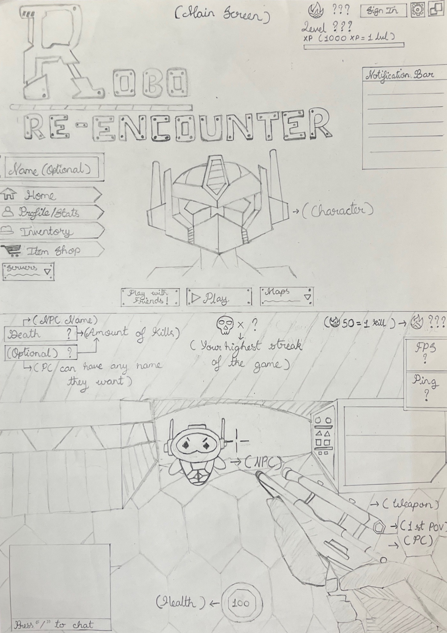

How do you plan to make your game engaging?

It Will Be a 3d game with 1st person view. I Will also use vibrant

colours to make the game more attractive.